24. Develop a system using UML for Online Stock Market System.

Activity diagram:

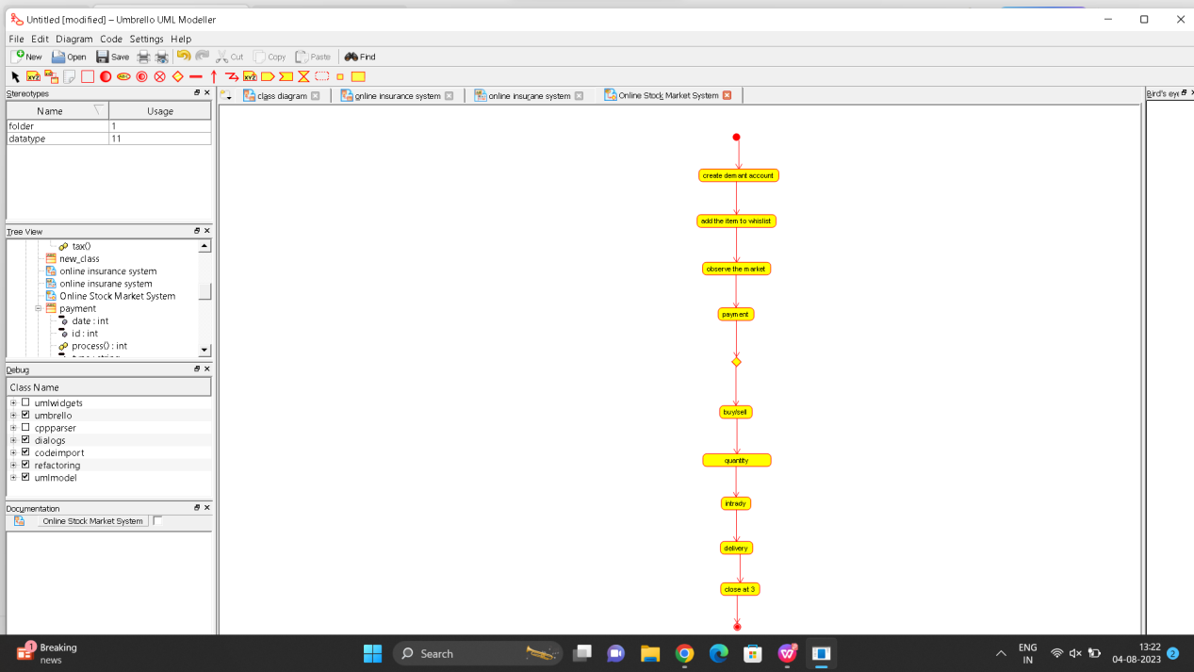

Class diagram:

